
NATIONAL INSTITUTE OF TECHNOLOGY PUDUCHERRY
(An Institution of National Importance under MHRD, Govt. of India)
KARAIKAL – 609 609

DEPARTMENT OF COMPUTER SCIENCE AND ENGINEERING
Roll Number: | CS19B1016 | Name | BOYINA AJAY SANTHOSH
Semester: | II | Class: | B TECH 1ST YEAR
Subject Code: | CS106 | Subject Name: | DATA STRUCTURES LABORATORY

2.1: BUBBLE SORT
Date:21.1.20

AIM:

To find the c program to sort the given array using bubble sort algorithm.

ALGORITHM:

1. start the program.
2 . declare the variables.
3 . Get the input from user.
4. Compare the adjacent elements from beginning and swap the element if the element is bigger than the adjacent element.
5. Repeat the above procedure until n-1 steps.
6. Output the result.
7. Close the program.

PROGRAM:

#include<stdio.h>
int bubblesort(int a[100],int n)
{
int i,j,temp;
for(i=0;i<n-1;i++)
{
for(j=0;j<n-i-1;j++)
{
if(a[j]>a[j+1])
{
temp=a[j+1];
a[j+1]=a[j];
a[j]=temp;
}
}
}
}
int main()
{
int a[100],i,n;
printf("Enter the value of n");
scanf("%d",&n);
printf("Enter array elements:\n");
for(i=0;i<n;i++)
{
scanf("%d",&a[i]);
}
bubblesort(a,n);
printf("The elements after sorting is:\n");
for(i=0;i<n;i++)
{
printf("%d\t",a[i]);
}
}

OUTPUT:

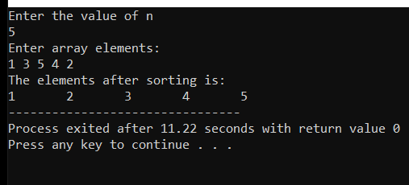

RESULT:

The program is successfully executed.

2.2 : SELECTION SORT

AIM:

To implement the selection sort by using c program.

ALGORITHM :

1. Start the program.
2 . Declare the variables.
3. Get the input from user.
4. Assume first element as minimum element and store the index of first element in min variable.
5. by using inner for loop we have to find the real minimum element and swap first element and minimum element.
6. Now assume second element as minimum element and repeat the same process.
7. This process until n-1 elements in outer for loop.
8. Now print the resultant sorted array.
9. Close the program.

PROGRAM:

#include<stdio.h>
int main(){
int i, j, count, temp, number[25];

printf("How many numbers u are going to enter?: ");
scanf("%d",&count);

printf("Enter %d elements: ", count);
for(i=0;i<count;i++)
scanf("%d",&number[i]);

for(i=0;i<count;i++){
for(j=i+1;j<count;j++){
if(number[i]>number[j]){
temp=number[i];
number[i]=number[j];
number[j]=temp;
}
}
}

printf("Sorted elements: ");
for(i=0;i<count;i++)
printf(" %d",number[i]);
return 0 ;
}
OUTPUT:

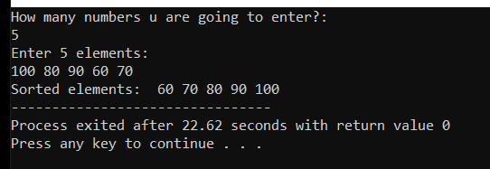

RESULT:

This program is successfully executed.

2.3 : INSERTION SORT

AIM :

To implement the insertion sort by using c program.

ALGORITHM:

1. Start the program.
2. Declare the variables.
3. input the array from the user.
4. Select the second element as key and insert it left side at correct position.
5. Repeat the above step for other elements using loop.
6. Output the result.
7. End the program.

PROGRAM:

#include <stdio.h>
int main()
{
int n, i, j, temp;
int arr[64];

printf("Enter number of elements\n");
scanf("%d", &n);

printf("Enter %d integers\n", n);
for (i = 0; i < n; i++)
{
scanf("%d", &arr[i]);
}
for (i = 1 ; i <= n - 1; i++)
{
j = i;
while ( j > 0 && arr[j-1] > arr[j])
{
temp = arr[j];
arr[j] = arr[j-1];
arr[j-1] = temp;
j--;
}
}
printf("Sorted list in ascending order:\n");
for (i = 0; i <= n - 1; i++)
{
printf("%d\n", arr[i]);
}
return 0;
}

OUTPUT:
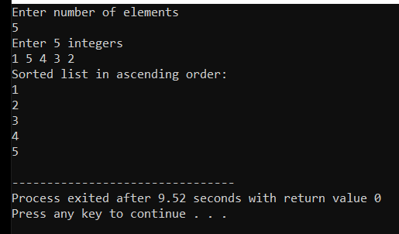

RESULT:

This program is successfully executed.

2.4: QUICK SORT

AIM:

To implement the quick sort by using c program.

ALGORITHM:

1. Start the program.
2. Declare the variables.
3. Input the variables.
4. Select a pivot element in the array and swap the pivot element and end index element when end is greater than start and return index end.
5. partition the array from first element index to pivot element index and from next index to last index.
6.repeat the same process using recursion function.
7. print the sorted array.
8.close the program.

PROGRAM:

#include<stdio.h>
int quicksort(int a[10],int lb,int ub)
{
int lock;
if(lb<ub)
{
lock=partition(a,lb,ub);
quicksort(a,lb,lock-1);
quicksort(a,lock+1,ub);
}
}
int partition(int a[10],int lb,int ub)
{

int start,end,pivot,temp,key;
start=lb;
end=ub;
pivot=a[lb];
while(start<=end)
{
while(a[start]<=pivot)
{
start++;
}
while(a[end]>pivot)
{
end--;
}
if(start<end)
{
temp=a[end];
a[end]=a[start];
a[start]=temp;
}
}
if(start>end)
{
key=a[end];
a[end]=a[lb];
a[lb]=key;
}
return end;
}
int main()
{
int lb,ub,a[100],i,n;
scanf("%d",&n);
for(i=0;i<n;i++)
{
scanf("%d",&a[i]);
}
lb=0;
ub=n-1;
quicksort(a,lb,ub);
for(i=0;i<n;i++)
{
printf("%d\t",a[i]);
}

}

OUTPUT:
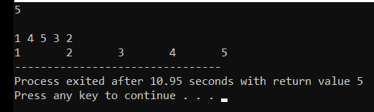

RESULT:

This program is successfully executed.

2.5: MERGE SORT

AIM:

To implement the MERGE sort by using c program.

ALGORITHM:

1. Start the program.
2. input the array from the user.
3. split the arrays from starting index to middle index and from next index to last index.
4. The above step will takes place by using recursive functions.
5. Now merge the splitted arrays in sorted way by using merge function recursively.
6. Print the resultant sorted array.
7. Close the resultant sorted array.

PROGRAM:

#include<stdio.h>
#include<conio.h>
int mergesort(int a[100],int lb,int ub)
{
int mid;
if(lb<ub)
{
mid=(lb+ub)/2;
mergesort(a,lb,mid);
mergesort(a,mid+1,ub);
merge(a,lb,mid,ub);
}
}
int merge(int a[100],int lb,int mid,int ub)
{
int i,j,k,b[100];
i=lb;
j=mid+1;
k=lb;
while(i<=mid && j<=ub)
{
if(a[i]<a[j])
{
b[k]=a[i];
i++;
}
if(a[j]<a[i])
{
b[k]=a[j];
j++;
}
k++;
}
if(i>mid)
{
while(j<=ub)
{
b[k]=a[j];
j++;
k++;
}
}
else
{
while(i<=mid)
{
b[k]=a[i];
i++;
k++;
}
}
for(k=lb;k<=ub;k++)
{
a[k]=b[k];
}
}
int main()
{
int i,k,n,a[100],lb,ub,mid;
scanf("%d",&n);
lb=0;
ub=n-1;
mid=(lb+ub)/2;
for(i=0;i<n;i++)
{
scanf("%d",&a[i]);
}
mergesort(a,lb,ub);
for(k=lb;k<ub;k++)
{
printf("%d\t",a[k]);
}
getch();
}

OUTPUT:
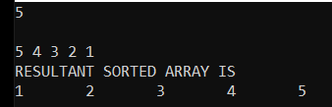

RESULT:

This program is successfully executed.

2.6: HEAP SORT

AIM:

To implement the HEAP sort by using c program.

ALGORITHM:

1. Start the program.
2. input the array from user.
3. construct a max heap using heapify algorithm.
4. construct a result array by getting the root elements of the heap.
5. output the sorted array.
6. end the program.

PROGRAM:
#include<stdio.h>
int maxheapify(int arr[], int n, int i)
{
int largest = i,temp;
int l = 2*i + 1;
int r = 2*i + 2;
if (l < n && arr[l] > arr[largest])
largest = l;
if (r < n && arr[r] > arr[largest])
largest = r;
if (largest != i)
{
temp=arr[i];
arr[i]=arr[largest];
arr[largest]=temp;
maxheapify(arr, n, largest);
}
}
int heapsort(int arr[], int n)
{
int temp,i;
for ( i = n / 2 - 1; i >= 0; i--)
maxheapify(arr, n, i);
// Heapifying process
for (i=n-1; i>=0; i--)
{
temp=arr[0];
arr[0]=arr[i];
arr[i]=temp;
// deletion process
maxheapify(arr, i, 0);
}
}
int main()
{
int arr[100];
int i,n ;
scanf("%d",&n);
for(i=0;i<n;i++)
{
scanf("%d",&arr[i]);
}
heapsort(arr, n);
for(i=0;i<n;i++)
{
printf("%d\t",arr[i]);
}
return 0;
}

OUTPUT:
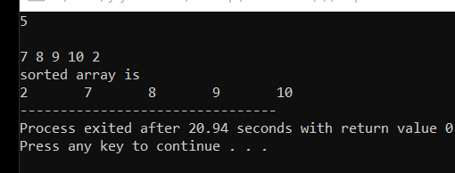

RESULT:

This program is successfully executed.

2.7: RADIX SORT
AIM:

To implement the HEAP sort by using c program.

ALGORITHM:

1. Start the program.
2. input the array from the user.
3. use the count sort technique for units digit place, after tens place and so on.
4. this process continues until the maximum number divided by pos variable=0
5. pos varies from 1,10,100 (multiplied by 10).
6. output the resultant sorted array.
7. close the program.

PROGRAM:

#include<stdio.h>
int radixsort(int a[10],int n)
{
int max,pos;
max=getmax(a,n);
for(pos=1;max/pos>0;pos=pos*10)
{
countsort(a,n,pos);
}
}
int countsort(int a[10],int n,int pos)
{
int count[10]={0};
int b[100],i;
for(i=0;i<n;i++)
++count[(a[i]/pos)%10];
for(i=1;i<10;i++)
count[i]=count[i]+count[i-1];
for(i=n-1;i>=0;i--)
b[--count[(a[i]/pos)%10]]=a[i];
for(i=0;i<n;i++)
a[i]=b[i];
}
int getmax(int a[10],int n)
{
int i,max=0;
for(i=1;i<n;i++)
{
if(a[max]<a[i])
{
max=i;
}
}
return a[max];
}
int main()
{
int a[10],n,i;
scanf("%d",&n);
for(i=0;i<n;i++)
{
scanf("%d",&a[i]);
}
radixsort(a,n);
print(a,n);
}
int print(int a[10],int n)
{
int i;
for(i=0;i<n;i++)
{
printf("%d\t",a[i]);
}
}

OUTPUT:

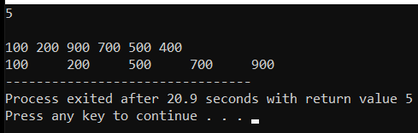

RESULT:

This program is successfully executed.

